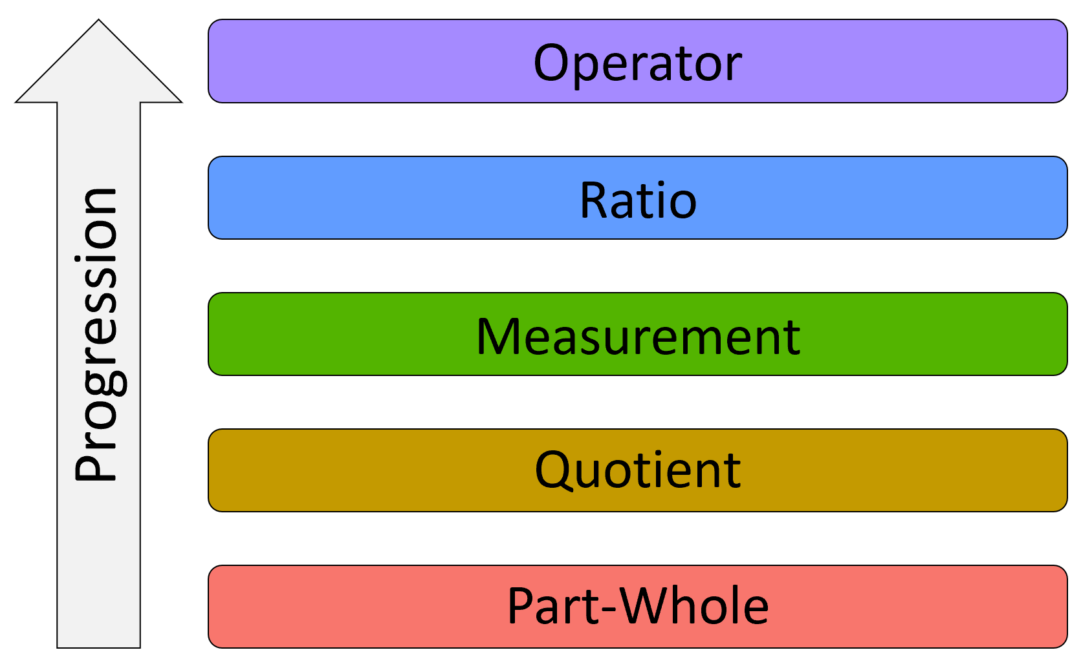Learning progressions are models that describe how students typically develop understanding of an important, big-picture concept by specifying increasingly sophisticated levels of understanding. These progressions are aligned with curriculum, and show how students should deepen their understandings of the concept over time. Here, we show a learning progression for fractions. In this case, students should start with a part-whole understanding and work their way up to understanding fractions as operators. Each level of a learning progression describes what a student at that level typically knows and can do. Additionally, the progression can indicate what misconceptions may be preventing a student from moving on to the next level of understanding. The table below describes each of the five levels of the fractions learning progression in detail.

In this reporting-system prototype, we use students’ responses to the *i-Ready Diagnostic* *Mathematics* to locate them at a given level of a learning progression. This means that instead of receiving only a numerical score, or a general proficiency level classification for a student, which can be hard to interpret, teachers can also get information about the specific skills and understandings that their students have demonstrated. Our hope is that identifying which level of understanding each student has likely developed will help teachers more efficiently target future instruction. Furthermore, using a learning progression for a concept that spans multiple grades can help facilitate teacher collaboration in the alignment of curriculum across grade levels.

The five levels shown in the figure and the table below are used in the rest of the prototype, and the colors shown for the levels in the figure below are used in the reporting system to help teachers quickly see which level of understanding their students likely have. Please note, however, that we have used an example of a fourth-grade class for this prototype, and Ratios are not included in the curriculum until sixth grade. Consequently, we have removed the blue Ratios level from the reporting to avoid confusion.

**Fraction conceptualizations learning progression**

|  |  |  |
| --- | --- | --- |
| Interpretation | Student Characteristics | Item Responses |
| Operator | **Understands that:**   * Multiplying a value by a fraction results in a value that is ths of the original value * Understands the difference between multiplying and dividing fractions | **Is able to:**   * Use multiplication to find a portion of a value * Determine that multiplying a value by a fraction with magnitude less than 1 will result in a value with smaller magnitude and multiplying by an improper fraction will result in a value with larger magnitude, and vice versa for division, without performing the calculations * Divide a value by a fraction |
| Ratio | **Understands that:**   * Ratios may be expressed in various forms * Ratios may represent either part-whole or part-part relationships * Ratios may represent rates * Equivalent ratios may be created by multiplying both parts by the same value   **May not yet understand that:**   * Multiplying a rate by a value can provide information about the overall situation (e.g., if a driver goes for 3 hours, they have gone miles) * The direction of effects for fraction operations are not the same as they are for whole numbers | **Is able to:**   * Identify part-whole and part-part relationships * Move between the various representational forms for ratios and rates   **Common Errors:**   * Selecting the wrong operation when solving problems involving proportional reasoning * Indicating that multiplication always results in a larger value and that division always results in a smaller value |
| Measurement | **Understands that:**   * Fractions represent unique numerical values * Two fractions are equivalent if they represent the same numerical value * Fractional values can be converted to decimals or percentages while maintaining their numerical value * Improper fractions may be rewritten as mixed numbers and vice versa * Fractions with different denominators may be compared or added if they are put into the same units   **May not yet understand that:**   * Fractions may be written as ratios and may represent part-part relationships or rates | **Is able to:**   * Create and identify equivalent fractions, including converting between improper fractions and mixed numbers * Order fractions and mixed numbers with different numerators and different denominators * Add and subtract fractions and mixed numbers with different denominators   **Common Errors:**   * Treating all ratios as part-whole * Treating rates as two independent values with different units |
| Quotient | **Understands that:**   * Fractional parts must be equal (“fair shares”) but may not appear the same * The fraction represents the division of by * Unit fractions can be iterated to reproduce the original whole or part of the whole * Dividing the same whole into more parts (larger denominator) results in smaller unit pieces   **May not yet understand that:**   * A fraction has its own specific value that can be uniquely placed on a number line. * The same fractional value may be represented in multiple ways | **Is able to:**   * “Share” a whole between a specified number of groups * Identify unit fractions * Use unit fractions to reproduce composite fractions , including the whole * Compare fractions with the same numerator and different denominators * Add and subtract composite fractions with the same denominator   **Common Errors:**   * Misplacing a fraction on a number line * Incorrectly comparing two fractions with different numerators and different denominators * Not recognizing improper fractions as valid |
| Part-Whole | **Understands that:**   * A fraction represents a specified number of parts out of the total number of parts   **May not yet understand that:**   * A whole must be partitioned equally * All parts of the whole must be used when partitioning | **Is able to:**   * Identify the number of specified and total parts in an area model or in a described situation. * Compare fractions with the same denominator and different numerators   **Common Errors:**   * Making unequal parts or fail to exhaust the whole when attempting an equipartitioning task * Treating the numerator and denominator of a fraction as unrelated values |